OSYS 1000 ASSIGNMENT 8

**UNIX**

**Due: Wednesday, Apr. 10, 2019 (in class)**

# Instructions

1. This assignment involves installing/activating and configuring some useful services on your CentOS virtual machine.
2. **Each section is worth 5 points and the goal is to get to 10 because the assignment is marked out of 10. So, in essence, you want to get two services working. If you want to get three services working, that will total to 15 and will be considered as a bonus (however, 3 services and 15 points is the maximum).**
3. THINGS MAY GO AWRY – VMWARE SNAPSHOTS/FULL BACKUP OF YOUR VIRTUAL MACHINE(S) DIRECTORY ARE HIGHLY RECOMMENDED BEFORE YOU BEGIN.
4. Topics for the assignment should have been covered in the following class videos:
   1. Linux Administration: Install from Binary vs. Source & Printing
   2. Linux Administration: Sharing Resources
5. You may also want to check out the additional resources listed in the recent Weekly Agendas for more help if necessary.
6. On the day that the assignment is due you will demonstrate the completion of the tasks to the instructor in class and get the checklist completed/marked.
7. That’s it.

sudo yum install -y samba

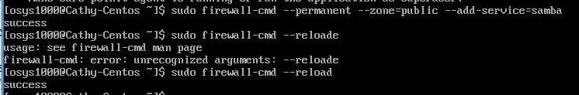

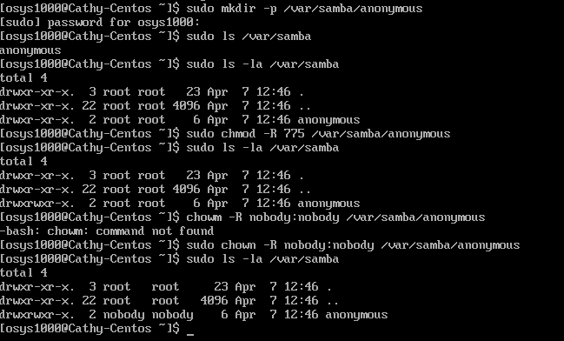

SELinux 보안설정에 있는 samba share 속성 변경





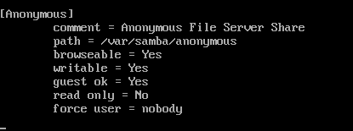

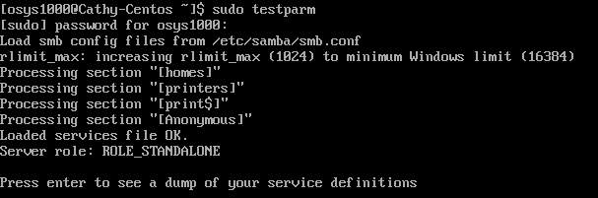

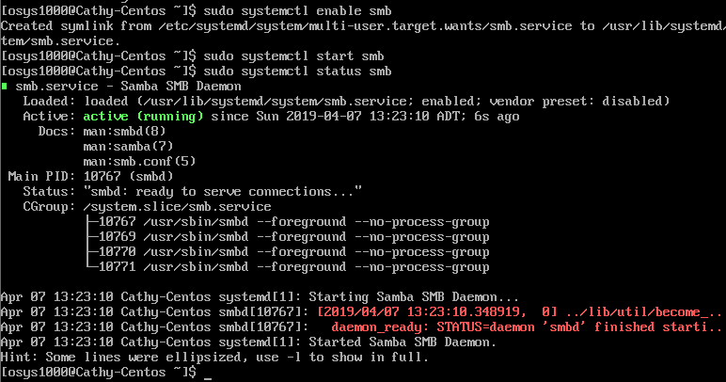

**Student Name: ____________________________________**

**Student ID: ____________________________________**

|  |  |  |
| --- | --- | --- |
| **SAMBA** | | |
| Item # | Item Description | Student has completed (Y/N)? |
| 1. | Install and configure the Samba service on your CentOS machine. |  |
| 2. | Make sure that the Samba service is not blocked by your Unix/Linux firewall service. **The Firewall service must be running and allowing Samba.**  **sudo systemctl status smb** |  |
| 3. | Set up a public shared folder via Samba to be used by all users on the system. You will **demonstrate this is working to the instructor by typing the following in a Windows Explorer window or at a Run command: \\[ virtual_machine_ip_address]**  **Cd /var/samba/anonymous/message.txt** | 2 pts. |
| 4. | Configure the Samba service to automatically start up on system startup. |  |

|  |  |  |
| --- | --- | --- |
| **NFS** | | |
| Item # | Item Description | Student has completed (Y/N)? |
| 1. | Install and configure the NFS server service on your CentOS machine. |  |
| 2. | Make sure that the NFS server service is not blocked by your Unix/Linux firewall service. **The Firewall service must be running and allowing NFS.**  **sudo systemctl status nfs**  **install an NFS client(Mint)**   * Mount -f nfs ip-addrr:remotefolder-path local-folder |  |
| 3. | Set up a public shared folder via NFS to be used by all users on the system. You will **demonstrate this is working to the instructor by mounting the share on your Mint machine.** | 2 pts. |
| 4. | Configure the NFS server service to automatically start up on system startup. |  |

|  |  |  |
| --- | --- | --- |
| **Apache** | | |
| Item # | Item Description | Student has completed (Y/N)? |
| 1. | Install and configure the Apache server service on your CentOS machine. |  |
| 2. | Make sure that the Apache service is not blocked by your Unix/Linux firewall service. **The Firewall service must be running and allowing HTTP.**  **Sudo systemctl status firewalld**  **Sudo firewall-cmd –state**  **Sudo firewall-cmd –list-service**  **Sudo firewall-cmd --list-port(http:80, https:443)** |  |
| 3. | Set up a custom default web page with your name in a H1 heading. You will **demonstrate this is working to the instructor in a browser on the host.** | 2 pts. |
| 4. | Configure the Apache service to automatically start up on system startup. |  |